**User Manual**

**for**

**Attendance Auditor Plus**

**Version 1.0 approved**

**Prepared by:**

Robert Airth

Adrian Haro

Skye Gibney

Cristian Puac

**December 11th, 2020**

**Table of Contents**

1. **Introduction**

**1.1 Purpose**

**1.2 Audience**

**1.3 Security**

**1.4 Overview**

1. **Getting Started**

**2.1 Accessing Application**

**2.2 Profile**

1. **Advanced Useability**
2. **Disclaimers**

**4.1 Performance Across Web Browsers and Platforms**

**4.2 Known Technical Issues**

1. **Introduction**

**1.1 Purpose**

The purpose of this document is to explain the functionalities and usage of the Attendance Auditor Plus (AAP) web application. The goal is to allow users to experience all of the features that AAP has to offer to give the best experience.

**1.2 Audience**

AAP is a web application that aids in the process of auditing the attendance of an event in a college campus setting. Event organizers could use this application to create an event, as well as audit the people that decide to show up to some event.This application also provides event information for students/guests on campus that may be searching for events to attend.

**1.3 Security**

Users of Attendance Auditor Plus have to create a profile in order to access the features of the application. Some information that is required are:

* Email address (used for authentication)
* First, Last Name
* Phone Number
* Organization/Department (if they are part of the same campus, as where the event is taking place)
* Category (guest, student, faculty, staff, classified)
* Password

Visible information for information email address, first, last name,

phone number, and organization/department.

**1.4 Overview**

Document can be sectioned into four succeeding components:

* **Getting started** - signing up and logging into the application, as well as understanding some certain privileges based on the category chosen: (guest, student, faculty, staff)
* Creating an event/viewing events
* RSVP to an event
* Managing inventory and checking out items

**2. Getting Started**

**2.1 Accessing the Application**

* To use the current version of Attendance Auditor Plus, the user can visit the Github Repository at <https://github.com/CS458-Capstone-Group/Attendance-Auditor-Plus> and download the file as a zip. After downloading
* **2.2 Home Page - Upcoming Events**

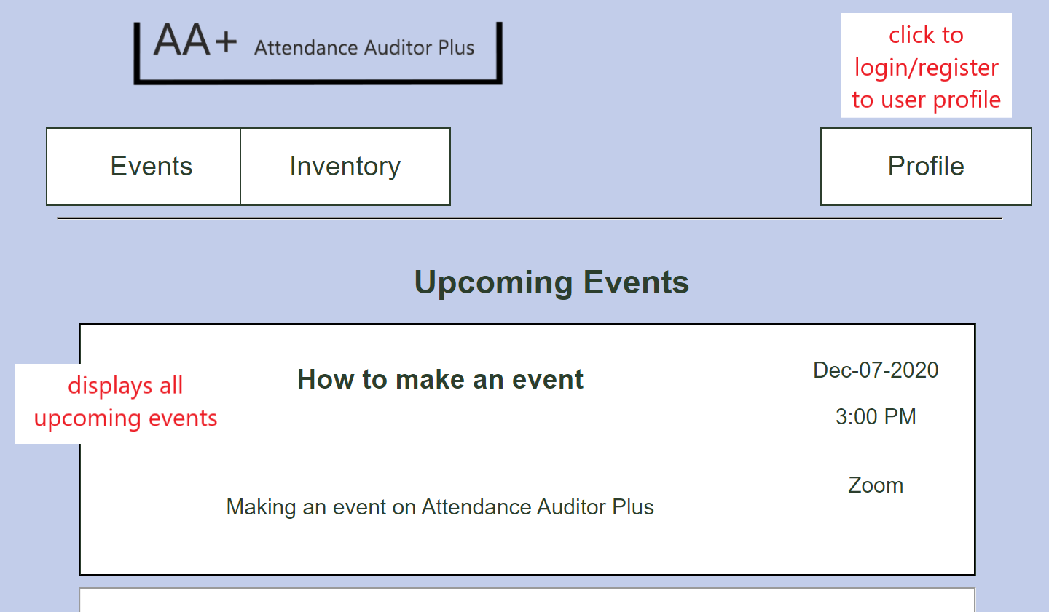

*Figure 2.2. Main Page of Attendance Auditor Plus*

**2.2.1 Header Tabs (Events, Inventory, and Profile tabs)**

**2.2.1.1** Left most tab is the **Events** tab that leads the user to the same page as the home page. It lists all the upcoming events that a user can RSVP. Each event can be clicked on for more details. **(Refer to Section 3.2)**

**2.2.1.2** The following tab is the **Inventory** tab, which takes the user to items that can be checked out by the user for any presentation/events purposes. **(Refer to Section 4)**

**2.2.1.3** On the far right side of the page is the Profile tab, which takes users to their profile information to view and edit. If a user is not logged in yet, the profile tab will take them to the login page. **(Refer to Section 2.3)**

**2.2.2 Upcoming events**

**2.2.2.1** Information on upcoming events can be found on this page, which lists the title and description of the events. The date and time is also listed on each event, however the date and time are absolute and do not take time zones into account.

* Users can click on the events tab and would be directed to the Events Details page, where they can view all the information on a specific event. Users can also RSVP for the event on this page. **(Refer to Section 3.2)**

**2.3 Profile**

**2.3.1 Login Page**

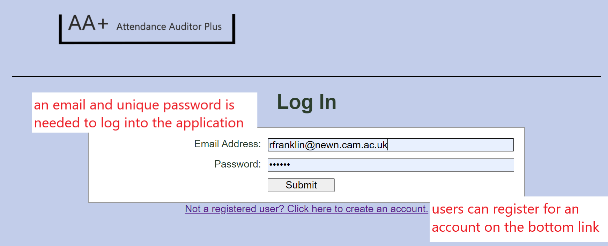

*Figure 2.3.1 Login Page*

**2.3.1.1 Email Address and Password Fields**

* Users can log into the their accounts by providing an email and unique password and click

**2.3.1.2 Submitting**

* Once the needed information is inputted, the submit button send you back to the homepage **(Refer to Section 2.2)**

**2.3.1.3 Register Link**

* Users that do not have an account can click the link below the login field to create an account through the Registration Page **(Refer to Section 2.3.2)**

**2.3.2 Register Page**

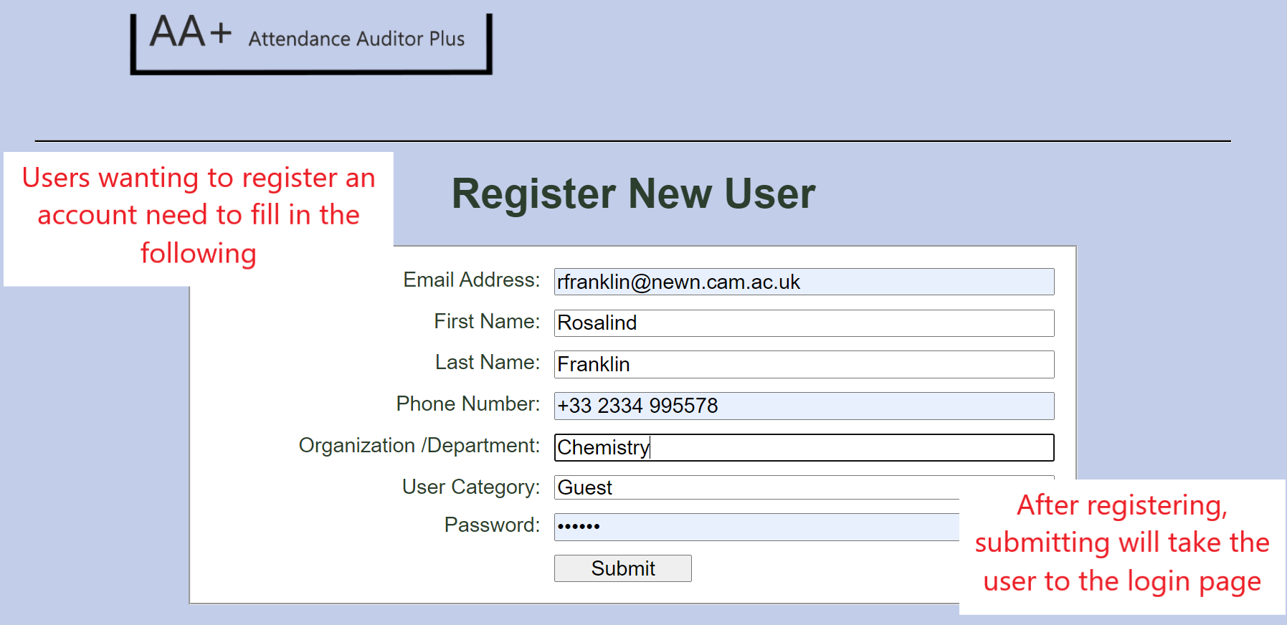

*Figure 2.3.2 Registration Page*

**2.3.2.1 Registering**

* Fields provided need to be filled out in order to register an account. Information needed from user includes:
  + ***Email Address:*** Unique to user; used for authentication
  + ***First Name***
  + ***Last Name***
  + ***Phone Number***
  + ***Organization/Department***: refers to a department on campus or any club/organization user is from.
  + ***User Category***: choose between ***guest, student, faculty, staff, classified***
  + ***Password:*** Unique to user

**2.3.2.2 Submit Button**

* Once the user submits the proper information, they are directed back to the login page **(Refer to 2.3.1: Login Page)**

**3. Events**

**3.1 Upcoming Events (refer to Section 2.2)**

**3.2. Event Details Page**

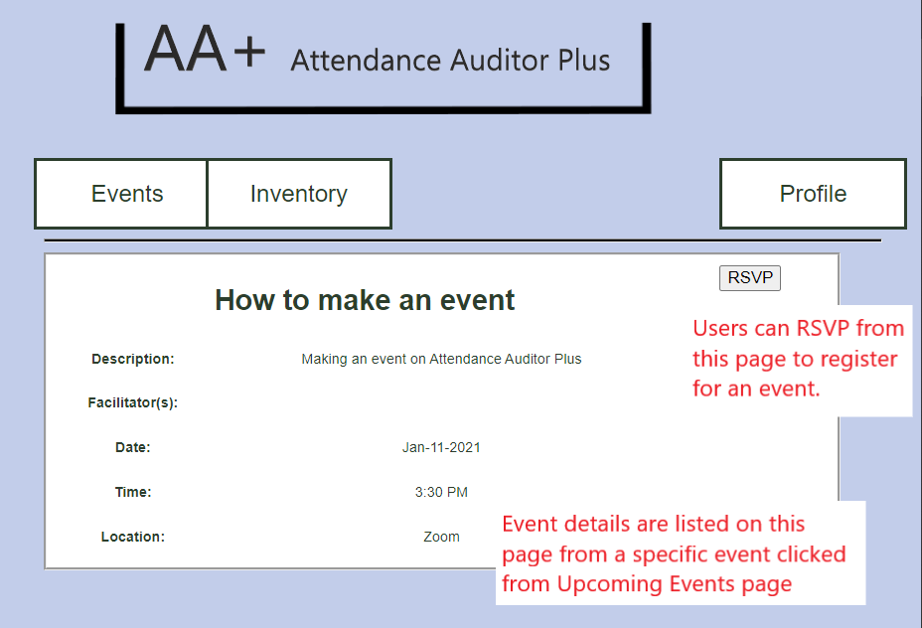

*Figure 3.2 Event Details Page*

**3.2.1 Event Details**

* Information for Events that include the following:
  + Event Title
  + Event Description
  + Facilitators (people who are in charge of the event)
  + Date
  + Time (does not take time zones into account)
  + Location

**3.2.2 RSVP**

* RSVP puts the user on an RSVP list for that event and takes the user back into the Upcoming Events page **(Refer to Section 2.2).**

**4. Inventory**

**4.1 Inventory List Page**

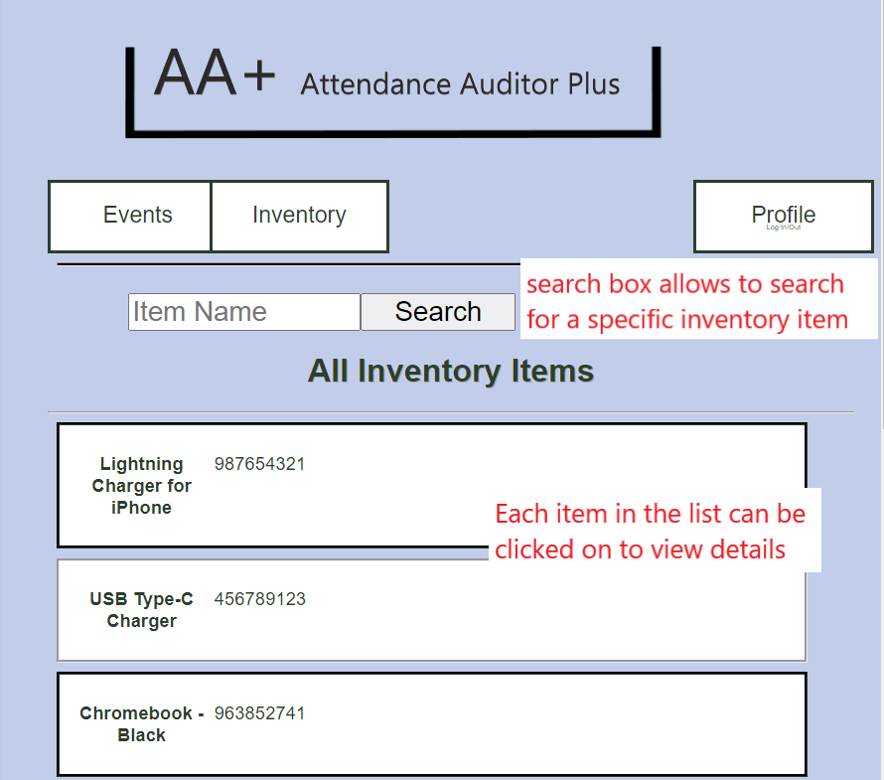

*Figure 4.1 Inventory List Page*

**4.1.1 Inventory List**

* All items on this list are part of the inventory that can be viewed. Each item can be clicked to see check further details

**4.1.2 Inventory Search**

* Users can search for items by using the provided textbox to search for any specific items

**4.2 Inventory Details Page**

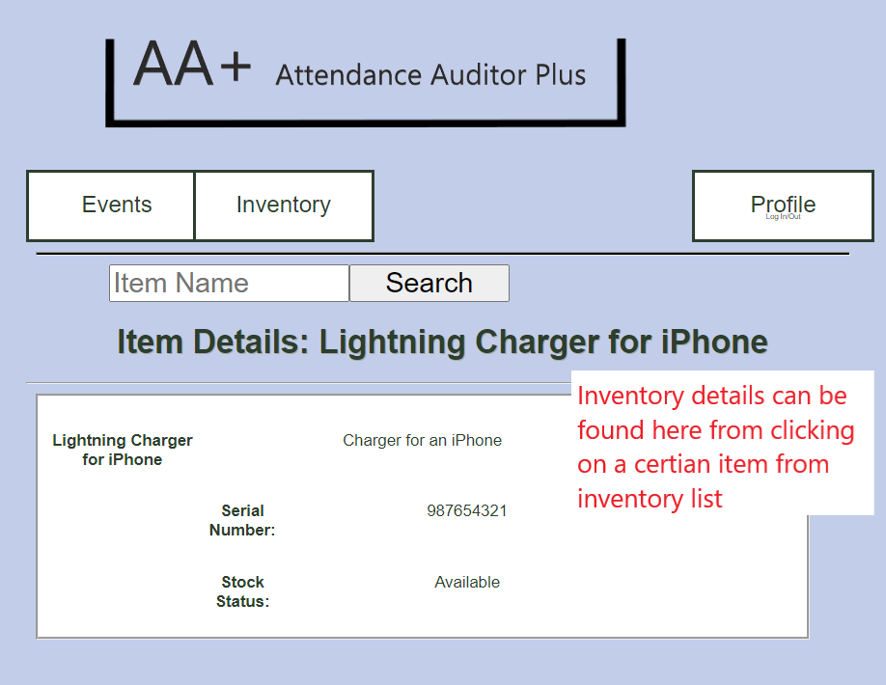

*Figure 4.2 Inventory Details Page*

**4.2.1 Inventory Details**

* Inventory details include the title and description of the item. A unique serial number is given to each item to make them distinct. There is also a status detail that provides the availability of the inventory item.

**5. Admin Privileges**

* A user can have admin privileges, which allows for some different privileges for admins to do. Some of the privileges include creating/editing events, adding/editing items to the inventory, checking items from the inventory, and auditing events.

**5.1 Admin User Homepage**.

* Similar to the Upcoming Events page **(Refer to Section 2.2)**, but with two major differences. Create Event and Audit buttons are added as part of admin privileges
* The Events and Inventory tabs serve the same function, but now are able to edit/delete items as well.

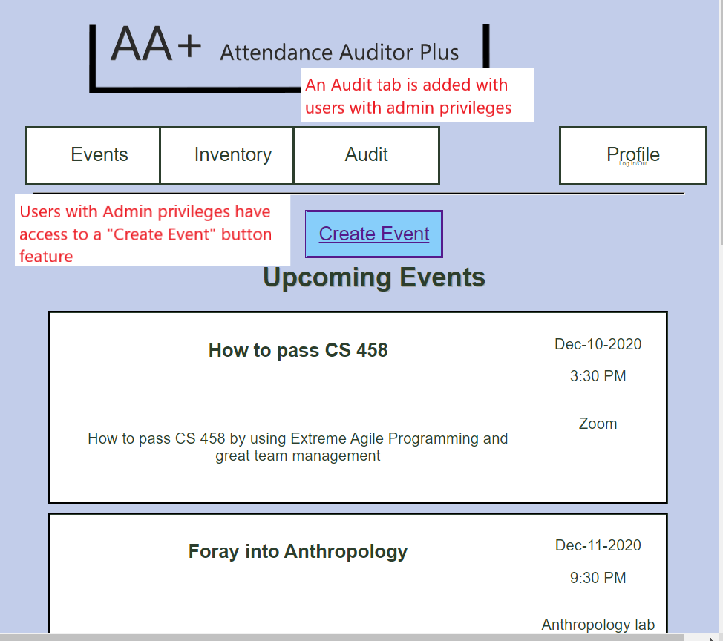

*Figure 5.1 Homepage for Admin Users*

**5.1.1 Create Event button**

* Events can be created by clicking this button, which requires the user to fill in required fields to create the event
* After saving, the users are redirected back to the Admin User homepage **(Refer to Section 5.1)**

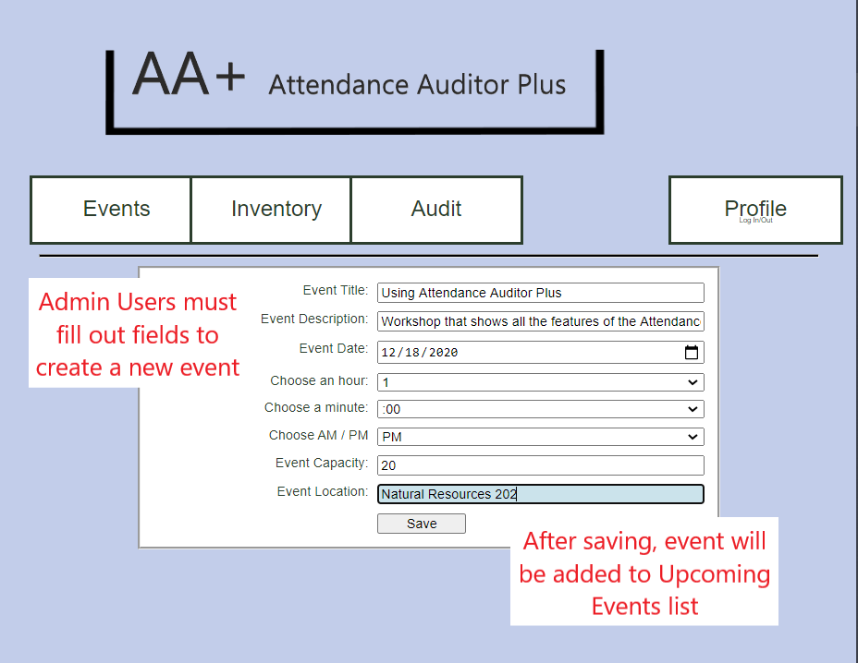

*Figure 5.1.1 Creating an Event page for Admin Users*

**5.1.2 Audit Button**

* Admin Users can use this button in order to find what events some users have actively attended. An email is needed to find what events a user has attended.

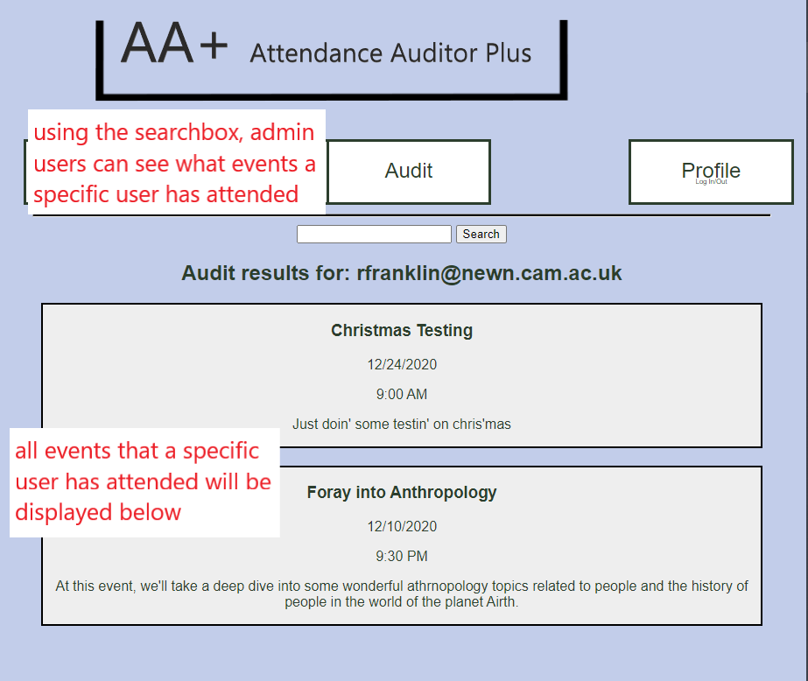

*Figure 5.1.2 Audit Button Page for Admin Users.*

**5.1.2.1. Search box**

* Typing a user member’s email address will show what events that user has attended

**5.2 Event Details Page (Admin User)**

* When viewing an Event Details page **(Refer to Section 3.2)**, Admin Users have the option to edit or delete events as they wish. There is also an Event Sign-In button that admin users can use to check off Users who are present at the event.

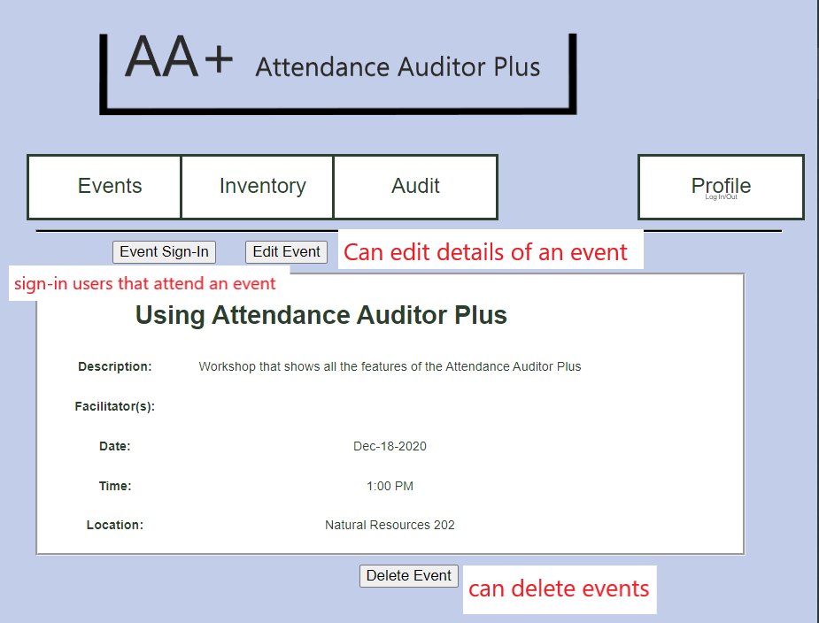

*Figure 5.2 Event Details Page for Admin Users*

**5.2.1 Edit Event**

**-** If